H.T No
Regulations:
A17

Sreenidhi Institute of Science and Technology
(An Autonomous Institution)
Code No: 6K301 Date: 28-Oct-2020 (FN)

B.Tech II-Year I-Semester External Examination, October - 2020 (Supplementary)
Strength of Materials-I (CIVIL)

Time: 2 Hours Max.Marks:75

Note: a) No additional answer sheets will be provided.
b) All sub-parts of a question must be answered at one place only, otherwise it will not be valued.
c) Missing data can be assumed suitably.

ANSWER ANY 5 OUT OF 8 QUESTIONS. EACH QUESTION CARRIES 15 MARKS.

1. | a) | Derive the relation between three elastic modules. | [8M]
 | b) | Two solid cylindrical rods AB and BC are welded together at B and loaded as shown in Fig.1.Take d₁=25 mm and d₂=40 mm. Find the average normal stress in the mid-section of (i) rod AB (ii) rod BC  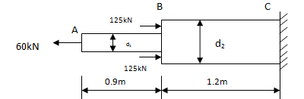  Fig : 1 | [7M]
2. |  | Construct S.F. and B.M. diagrams for the following loaded overhang beam as shown in Fig.2.Also locate the point of contra flexure.  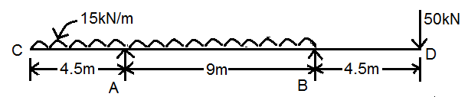 | [15M]
3. | a) | Derive the simple bending equation. | [8M]
 | b) | A timber beam of rectangular section supports a load of 30KN uniformly distributed over a span of 4m. If the depth of the beam section is twice the width and the maximum bending stress is not to exceed 7.0Mpa, find the dimensions of the beam section. | [7M]
4. |  | A simply supported beam is 6.5 m long and has flexural rigidity of 3.2 MNm². It a carries a point load of 45kN at the middle and a UDL of 20kN/m along its entire length. Calculate  slope at the ends and max. deflection | [15M]
5. | a) | Derive an expression for the stresses on an oblique section of a rectangular body, when it is subjected to direct stresses in two mutually perpendicular directions along with clockwise shear stress | [8M]
 | b) | A point in a strained material is subjected to a tensile stress of 130 MPa and a clock wise shear stress of 45 MPa. What are the values of normal and shear stresses on a plane inclined at 45º with the normal to the tensile stress | [7M]
6. |  | The shear force acting on a section of a beam is 120KN. The section of the beam is of T-shaped with 200mm flange width and overall depth 250mm. The flange thickness and web thickness are 50mm. Moment of inertia about its horizontal neutral axis is 1.134x10⁸ mm⁴. Find the shear stress at neutral axis and at the junction of the web and flange. Also sketch the shear stress distribution across the section | [15M]
7. |  | Three bars made of copper; zinc and aluminum are of equal length and have cross section 500, 750 and 1000 square mm respectively. They are rigidly connected at their ends. If this compound member is subjected to a longitudinal pull of 250 k N, estimate the proportional of the load carried on each rod and the induced stresses. Take the value of E for copper = 1.3 x 105 N/mm2, for Zinc=1.0 105 N/mm2 and for aluminum = 0.8 x 105 N/mm2 | [15M]
8. |  | A bolt is required to resist an axial tension of 25 kN and a transverse shear of 20 kN. Find the safe size of the bolt by  i) Maximum strain energy theory  ii) Maximum distortion energy theory and  iii) Maximum shear stress theory.  The elastic limit of the material is 300 N/mm², Factor of safety = 3, Poisson’s ratio = 0.25, modulus of elasticity = 200 kN/mm² | [15M]

-- 00 -- 00 –

